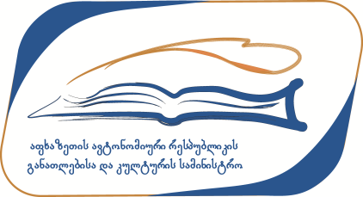

Apposition №1
Confirmed by minister of The ministry
of education and culture of the
autonomous republic of Abkhazia on account of
the statement № 66 of year 2018, February the 12TH.

Conference registration form
Scientific Conference under the
“Cultural property protection program” (program code 06/10/01)

Topic of the conference: “Cultural Properties in Disputed Territories”

Name, Surname:
Work occupation:
Position:
Name of conference topic:
phone : FAX:
Web page http:// Email:
Registration date:
Abstract of the Paper in English language(100 -120 Words) :

